

Course program

AOTrauma Regional Course—Advanced Principles of Fracture Management

May 03 – 06 May 2014 Krakow, Poland

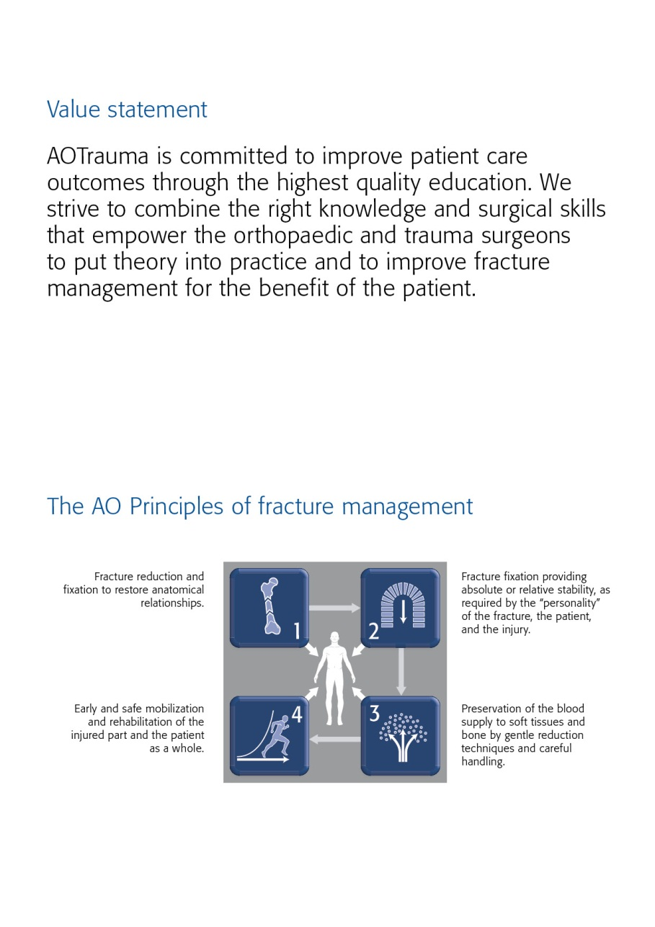

The first AO Course was held in Davos in 1960—these early courses pioneered psychomotor techniques by teaching practical skills of AO Techniques. Since those early days over 250,000 surgeons and 135,000 ORP staff from over 110 countries have attended AO Courses—we now launch AOTrauma to move our education to the next level.

Dear AOTrauma course participant

Welcome to AOTrauma’s Davos Congress of Courses 2013. AOTrauma provides a wide range of relevant courses and Continuing Professional Development (CPD) activities all designed to meet your specific professional needs. We are confident that you will find your course as well as the CPD extracurricular and networking experiences professionally rewarding.

With a global reputation for innovation, leadership, and excellence in Continuing Medical Education (CME) and CPD, the AOTrauma Clinical Division and the AO Education Institute are transforming education. AOTrauma is constantly expanding its portfolio of educational activities available to you. Continuing Medical Education is no longer just about face-to-face courses. Portfolios are being created to address the specific clinical problems that you encounter every day. Visit the AOTrauma home page (www.aotrauma.org) as new assets are being added every week.

The AOTrauma Davos Congress of Courses offers more than just a course experience. Your primary focus is active engagement in your course. In addition, we encourage you to:

* Interact with over 320 international faculty and discuss the specific issues you face
* Expand your professional network by establishing new relationships with colleagues that include faculty and participants from over 80 countries
* Learn about the latest innovations in patient treatment by attending the Technology Innovation Program (TIP) which offers activities every day
* Visit and speak with staff and surgeons from the AO Foundation’s Clinical Divisions and Institutes. Both the exhibits in the AO World and the “Insight into the AO Center Davos” allow you to learn about the AO’s ongoing activities and the resources available to support you in your clinical work
* Focus your self-directed learning by attending some of the many CPD activities that will take place every day
* Attend one of the global webinar broadcasts as a member of the “in studio” audience

To further improve health outcomes, all of these CPD activities are part of AOTrauma’s continuing efforts to design and deliver innovative continuous learning activities for trauma and orthopedic healthcare professionals. You can find the details of all CPD activities in your brochure on **Educational Programs for Individual CPD.**

Your current level of knowledge, attitudes, and skills will be challenged throughout the week. The best-in-class curriculum and faculty will provide you a memorable learning experience that will remain with you for a lifetime.

If you enjoy the experience during this week and would like to stay in touch with the elite AOTrauma organization, we invite you to become a member of AOTrauma. Membership for medical doctors (and DO’s) requires only a completed AOTrauma Basic Principles Course and the payment of a reasonable yearly fee (see AOTrauma membership information in this brochure).

Kodi Kojima Nikolaus Renner

*Photo Photo*

Kodi Kojima Nikolaus Renner

Chairperson AOTrauma Chairperson AOTrauma

Education Commission International Board

Goal of the course

The AOTrauma Course—Advanced Principles of Fracture Management teaches current concepts and fundamental principles in the treatment of complex injuries. The latest techniques in operative fracture management are incorporated in the course.

Target participants

The AOTrauma Course—Advanced Principles of Fracture Management is targeted at surgeons at the threshold of becoming independent surgeons and taking over decision-making responsibility for the treatment of complex injuries.

It builds upon the AO Principles and techniques of the Basic course, making it necessary for participants to have completed the AOTrauma Course—Basic Principles of Fracture Management previously. They also must be actively involved in trauma management.

Course objectives

At the end of this course, participants will be able to:

* Apply reduction techniques in fracture management with attention to soft tissues
* Assess and treat complex fractures using advanced application techniques
* Demonstrate strategies for assessing and treating open fractures and soft-tissue injuries, as well as managing polytrauma patients
* Evaluate, classify, and formulate a treatment plan for pelvic injuries and acetabular fractures
* Recognize complications and manage accordingly

Course description

Online precourse self-assessment prepares participants for the course and allows the faculty to tailor the course to the participants' needs. Before attending the course, participants are expected to complete an online module on reduction techniques.

The course will be taught in a modular format. Each module consists of evidence-based lectures, which will cover the key information required. Discussing cases in small groups will help participants to understand decision-making and management skills. Debates and interactive sessions will promote interactivity between faculty and course participants. In practical exercises participants will be trained in the application of various techniques.

Participants may also bring their own cases for discussion with the faculty.

After the course an online postcourse self-assessment will provide participants with important feedback on what they have learned.

Chairpersons

**Emilio Fantin Endre Varga**

Cordoba, Argentina Szeged, Hungary

Faculty

|  |  |  |  |
| --- | --- | --- | --- |
| Aithal | Vasudev | Oman | [vasudev.aithal@gmail.com](mailto:vasudev.aithal@gmail.com) |
| Alyami | Ali | Saudi Arabia | alyamia@yahoo.com |
| Barbosa | Paulo | Brazil | prbtl1@mac.com |
| Baumgaertel | Friedrich | Germany | f.baumgaertel@t-online.de |
| Bavonratanavech | Suthorn | Thailand | suthorn@gmail.com |
| Bel | Jean-Christophe | France | [jean-christophe.bel@chu-lyon.fr](mailto:jean-christophe.bel@chu-lyon.fr) |
| Cadena Mendez | Luis | Mexico | luiscadena@prodigy.net.mx |
| Cole | Peter | USA | peter.a.cole@healthpartners.com |
| Concha Sandoval | Juan | Colombia | jmconcha40@hotmail.com |
| Crist | Brett | USA | cristb@health.missouri.edu |
| Cuadros | Miguel | Spain | m.cuadros@telefonica.net |
| Eslava | Santiago | Argentina | eslavasantiago@hotmail.com |
| Fantin | Emilio | Argentina | emiliofantin55@gmail.com |
| Fazio | Alejandro | Argentina | atatofazio@hotmail.com |
| Felicissimo | Paulo | Portugal | paulo.felicissimo@gmail.com |
| Fernández | Sergio | Chile | fernandez.sc@gmail.com |
|  |  |  |  |
|  |  |  |  |
|  |  |  |  |
|  |  |  |  |
|  |  |  |  |
|  |  |  |  |
|  |  |  |  |
|  |  |  |  |
|  |  |  |  |
|  |  |  |  |
|  |  |  |  |
|  |  |  |  |
|  |  |  |  |
|  |  |  |  |
|  |  |  |  |
|  |  |  |  |
|  |  |  |  |
|  |  |  |  |
|  |  |  |  |
|  |  |  |  |
|  |  |  |  |
|  |  |  |  |
|  |  |  |  |
|  |  |  |  |
|  |  |  |  |
|  |  |  |  |
|  |  |  |  |

Saturday, May 3, 2014

|  |  |  |
| --- | --- | --- |
| Time | AGENDA ITEM | WHO |
| 08:00–08:15 | Welcoming remarks and course organization |  |
| **Module 1** | **Revision module** |  |
| 08:15–08:30 | Tissue vitality and injury effect |  |
| 08:30–08:45 | Tissue protecting, reduction techniques, types of stability |  |
| 08:45–09:05 | Evolution of plate design and function – indication for locked plating |  |
| 09:05–09:20 | MIPO advantages and problems |  |
| 09:20–09:40 | Imagine techniques |  |
| 09:40–10:00 | Coffee Break |  |
| 10:00–11:00 | Discussion group 1: Application of principles |  |
| **Module 2** | **Fractures around the shoulder** |  |
| 11:00–11:15 | Fractures of the clavicle – when and how to operate |  |
| 11:15–11:30 | Fractures of the scapula – indications for surgery |  |
| 11:30–11:45 | Proximal humerus fractures – fix or replace? |  |
| 11:45–12:10 | Summary of module 2 |  |
| 12:10–13:20 | Practical exercise 1: Philos proximal humerus |  |
| 13:20–14:30 | Lunch |  |
| **Module 3** | **Fractures of upper extremity** |  |
| 14:30–14:45 | Complex humeral shaft fractures – how to fix them? |  |
| 14:45–15:00 | Distal humerus intraarticular fractures and complications |  |
| 15:00–15:15 | Fracture dislocation of the elbow |  |
| 15:15–15:30 | Distal radius fractures |  |
| 15:30–16:00 | Summary of module 3 |  |
| 16:00–17:15 | Practical exercise 2: C1 fracture of the distal humerus – fixation with the LCP (medial and lateral plate) |  |
| 17:15–17:30 | Discussion group 2: Fractures of upper extremity |  |

Sunday, May 04, 2014

|  |  |  |
| --- | --- | --- |
| Time | AGENDA ITEM | WHO |
| 08:00–09:00 | Practical exercise 3: Distal radius fractures (LCP) |  |
| **Module 4** | **Proximal femur fractures** |  |
| 09:00–09:15 | Femoral neck fractures – different patients – different problems |  |
| 09:15–09:30 | Intertrochanteric fractures – treatment options and outcomes |  |
| 09:30–09:45 | Current concepts and outcomes of subtrochanteric fractures |  |
| 09:45–10:05 | Summary of module 4 |  |
| 10:05–10:25 | Coffe Break |  |
| **Module 5** | **Femoral shaft and distal femur fractures** |  |
| 10:25–10:40 | Femoral shaft fractures – plate fixation |  |
| 10:40–10:55 | Distal femur fractures treatment options and outcomes |  |
| 10:55–11:10 | What’s new in IMN? |  |
| 11:10–11:35 | Summary of module 5 |  |
| 11:35–12:50 | Practical exercise 4: Distal femur fractures C1 LCP |  |
| 12:50–14:00 | Lunch |  |
| **Module 6** | **Tibial fractures** |  |
| 14:00–14:15 | Tibial shaft fractures (proximal, distal and segmental) |  |
| 14:15–14:30 | Complex tibial plateau fractures |  |
| 14:30–14:45 | Early and definitive treatment of pilon fractures |  |
| 14:45–15:00 | Specific and complex malleolar fractures |  |
| 15:00–15:25 | Summary of module 6 |  |
| 15:25–16:25 | Pracitical exercise 5: Tibial plateau |  |
| 16:25–16:45 | Coffee Break |  |
| **Module 7** | **Foot injuries** |  |
| 16:45–17:00 | Calcaneal fractures – predicting and avoiding problems |  |
| 17:00–17:15 | Talar neck fractures and complications |  |
| 17:15–17:30 | Navicular and Lisfranc injuries and complications |  |
| 17:30–17:55 | Summary of Module 7 |  |
| 17:55–19:15 | Discussion group 3: Fractures of lower extremity |  |

Monday, May 05, 2014

|  |  |  |  |  |
| --- | --- | --- | --- | --- |
| Time | AGENDA ITEM | | WHO | |
| 08:00–09:30 | Practical exercise 6: Pilon fracture | |  | |
| 09:30–09:45 | Coffee Break | |  | |
| **Module 8** | **Pelvis** | |  | |
| 09:45–10:00 | State of art in the management of multiple injured patients | |  | |
| 10:00–10:20 | Evaluation and emergency management of pelvic ring injuries | |  | |
| 10:20–10:40 | Pelvic ring fixation techniques – indications and concepts | |  | |
| 10:40–10:55 | Posterior approach to the hip joint | |  | |
| 10:55–11:20 | Summary of the module 8 | |  | |
| 11:20–13:00 | Practical exercise 7: Emergency and definitive external fixation for pelvic disruption – plating of the pubic symphysis and simple posterior wall fracture | |  | |
| 13:00–14:15 | Lunch | |  | |
| **Module 9** | **Difficult fracture problems** | |  | |
| 14:15–14:30 | Open articular fracture | |  | |
| 14:30–14:50 | Mangled extremity management | |  | |
| 14:50–15:05 | Osteoporotic fractures | |  | |
| 15:05–15:20 | Periprostetic fractures | |  | |
| 15:20–15:40 | Summary of module 9 |  | |
| 15:40–16:00 | Coffee Break | |  | |
| 16:00–17:15 | Discussion group 4: Pelvis | |  | |
| **Module 10** | **Nonunions** | |  | |
| 17:15–17:30 | Treatment of metaphyseal and diaphyseal nonunions | |  | |
| 17:30–17:45 | Bone grafts and bone substitutes to promote fracture union | |  | |
| 17:45–18:00 | BMP and tissue engineering | |  | |
| 18:00–18:15 | Summary of module 10 | |  | |

Tuesday, May 06, 2014

|  |  |  |  |
| --- | --- | --- | --- |
| 08:00–09:15 | Practical exercise 8: Calcaneal fracture plate fixation | |  |
| 09:15–09:30 | Coffee Break | |  |
| **Module 11** | **Risk factors and complications** | |  |
| 09:30–09:45 | Infection after ORIF | |  |
| 09:45–10:00 | DVT prophylaxis | |  |
| 10:00–10:15 | Violation of AO principles | |  |
| 10:15–11:30 | Discussion group 5: Complications | |  |
| 11:30–11:45 | | Closing remarks |  |

Course organization

**AOTrauma**

George Clay

Clavadelerstrasse 8

7270 Davos, Switzerland

Phone: +41 81 414 27 25  
Fax: +41 81 414 22 84

Email: [gclay@aotrauma.org](mailto:gclay@aotrauma.org)

Website: www.aotrauma.org

Course logistics

**DePuy Synthes**

Lilian Rubin

Luzernstrasse 21

4528 Zuchwil, Switzerland

Tel +41 32 720 46 70

Fax +41 32 720 46 89

Email rubin.lilian@synthes.com

Website [www.depuysynthes.com](http://www.depuysynthes.com)

Course information

**Course fee**

Early bird valid until 31 March 2014 € 800.00

After 31 March 2014 € 1'000.00

Included in course fee are conference bag with documentation, coffee breaks, lunches, course banquet and course certificate.

**Accreditation**

AOTrauma Courses are accredited for continuing medical education (CME) programs. The number of credit points or hours varies from country to country. The final information and number of credit points will be distributed with the course certificate.

**Evaluation guidelines**

All AOTrauma courses apply the same evaluation process, either ARS (audience response system) or paper and pencil questionnaires. This will help AOTrauma to ensure that we continue to meet your training needs. In some regions, CME accreditation is dependent on the participant’s evaluation results.

**Intellectual property**

Course materials, presentations, and case studies are the intellectual property of the course faculty. All rights are reserved. Check hazards and legal restrictions on www.aotrauma.org/legal.

🡪 **Recording, photographing, or copying of lectures, practical exercises, case discussions, or any course materials is strictly forbidden. Participants violating intellectual property will be dismissed.**

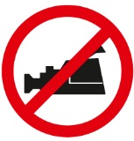

The AO Foundation reserves the right to film, photograph, and audio record during their events. Participants must understand that in this context they may appear in these recorded materials. The AO Foundation assumes participants agree that these recorded materials may be used for AO marketing and other purposes, and made available to the public.

**Security**

Security check at the entrance of the building. Wearing of a name tag is compulsory during lectures, workshops, and group discussions.

**No insurance**

The course organization does not take out insurance to cover any individual against accidents, thefts or other risks.

**Mobile phone use**

Mobile phone use is not allowed in the lecture halls and in other rooms during educational activities. Please be considerate of others by turning off your mobile phone.

**Dress code**

Casual

**Course language**

English

Course venue

**Qubus Hotel Kraków**   
ul Nadwiślańska 6  
30-527 Kraków  
Tel.: +48 12 374 5 100  
Fax.: +48 12 374 5 200  
[krakow@qubushotel.com](mailto:krakow@qubushotel.com)  
[www.qubushotel.com/en/hotels/krakow/1/#main](http://www.qubushotel.com/en/hotels/krakow/1/#main)  
  
**Accommodation for participants**  
Book your hotel room **until 04 April 2014**, The number of rooms is limited.  
Reservation and payment will be done individually by participants.  
Accomodation is not included in the Registration fee, it has to be paid directly to the Hotel.  
  
**Room rates**Twin for sgl use 100 euro. Breakfast+VAT included.  
Check in at 2 p.m.  
Check out until 12:00 of the next day.

**Hotel reservation & distances**

For reservation please use the hotel registration form (download [www.aotrauma.org](http://www.aotrauma.org/)) and fax or email it directly to the hotel.

Distances from to Hotel:

• Railway station 2,8 km

• Bus station 3 km

• Airport 13,7 km

Upcoming courses  
Please visit our website for upcoming courses <http://www.aotrauma.org/coursedirectory.aspx>



AOTrauma Clavadelerstrasse 8, 7270 Davos Platz, Switzerland

Phone +41 81 414 27 20, F +41 81 414 22 84, courses@aotrauma.org

Logistics and support provided by an educational grant from DePuy Synthes.